**Updating from a Paper-Based to an Electronic**

**Display Order Information System**

BUSI 3402 Systems Analysis & Design

Professor: Samira Farivar

T.A.: Lina Shikhhassan

**Group 4**

Brandon Marsh

Mitchell Dumouchel

Nick Jeffs

Steven Rhodes

April 7, 2020

**Table of Contents**

Executive Summary -------------------------------------------------------------------------------------------------- 3

Project Overview

Project Overview -------------------------------------------------------------------------------------------- 4

As-is System ------------------------------------------------------------------------------------------------- 4

Problem/Issue ------------------------------------------------------------------------------------------------ 5

Project Scope & Objective --------------------------------------------------------------------------------- 6

Feasibility Study

Operational Feasibility -------------------------------------------------------------------------------------- 7

Economic Feasibility ---------------------------------------------------------------------------------------- 8

Technological Feasibility ----------------------------------------------------------------------------------- 8

Scheduling Feasibility --------------------------------------------------------------------------------------- 9

Requirements Analysis

User Requirements ------------------------------------------------------------------------------------------ 10

Functional Requirements ----------------------------------------------------------------------------------- 10

Non-Functional Requirements ---------------------------------------------------------------------------- 11

Scope of Proposed Solution ------------------------------------------------------------------------------- 12

System Modelling ----------------------------------------------------------------------------------------------------- 13

Development Strategy ------------------------------------------------------------------------------------------------ 14

Database Design ------------------------------------------------------------------------------------------------------ 16

System Architecture -------------------------------------------------------------------------------------------------- 17

User Interface Design ------------------------------------------------------------------------------------------------ 18

Security & Performance ---------------------------------------------------------------------------------------------- 20

Implementation Plan

Budget -------------------------------------------------------------------------------------------------------- 22

Timeline ------------------------------------------------------------------------------------------------------ 22

Appendices

Appendix A: Extra Diagrams ----------------------------------------------------------------------------- 23

Appendix B: Techniques --------------------------------------------------------------------------------- 24

Appendix C: References ---------------------------------------------------------------------------------- 25

**Executive Summary**

This report serves to analyze the current information system of the restaurant Captain’s Boil and provide the necessary recommendations to improve and optimize the system. Captain’s Boil is a casual seafood dining restaurant that currently uses a paper-based information system for communicating orders to the kitchen. Several issues arise due to this outdated system: slow service time, mistakes in orders, poor communication channels, etc.   
 It is recommended that Captain Boil replace its current system with an electronic based information system. With this new system customers will have their orders taken from servers with handheld tablets. The order is then dispatched to the kitchen staff by the electronic system, outputting the order to multiple touch-screen monitors, one for each of the respective stations in the kitchen. Finally, the system will allow users to pay for their meal and complete the customer order process within the integrated POS system. Overall, the main addition to the as-is system is the introduction of new technology (monitors, tablets, new POS).

Due to the popularity of electronic-based POS systems for restaurants, it is advisable that the restaurant purchase a pre-existing system. This satisfies the important needs of the restaurant by obtaining a low-cost system in a short period of time that meets the technical requirements of the restaurant.

Several benefits will arise with this new streamlined system including: increase in sales, increased accuracy of orders, improved kitchen communication, etc. Overall, the system has an upfront cost of $3000 with additional monthly expenses of $223/month. The system will provide an increase in revenue of 5% per month and decrease in inventory waste resulting in total monthly savings of $8500 per month. The implementation timeline is relatively short as it will take a total of one month to procure, transport, install, and train the staff to use the system. Overall, the project has a short time schedule, provides economic value to the company, is technically feasible, and will be used effectively by the staff members and customers alike.

**Project Overview**

**Company Overview**

Captain’s Boil is a contemporary casual dining restaurant chain established in 2016 with 23

locations operating all over Canada. The restaurant’s niche is boiled seafood based upon the traditional

Louisiana boil: “big community gatherings where crawfish, shrimp and crab are boiled in big pots.”

Captain’s Boil “spices” this classic model up with “Asian aromatics such as lemon grass and ginger”

added to their signature Captain’s Boil Sauce. In addition to the delicious food, guests are treated with a

unique eating experience where plates are ditched for bags containing the sauce of their choosing mixed

in with the food item of choice. Customers can choose from an assortment of seafood staples such as

lobster, Dungeness crab, snow crab, king crab, mussels, clams, shrimp and crawfish. For the purposes of

this report we will be focusing on the internal processes of the restaurant, more specifically on the current

ordering system that currently exists at one of the Ottawa locations.

**As-is system**

Currently the restaurant uses a paper-based information system for communicating orders to

the kitchen. The system begins with the process of the customer’s order being taken. Orders are taken by

front-staff on paper and are then inputted into the system through a computer behind the front counter.

This computer also manages clock-in/clock-out, guests orders, the cash register, POS, as well as the relay

of order data to the kitchen where the order is then printed out on paper for the kitchen staff. The

computer also serves as a database for past orders; if a customer was missing an item, front staff would

need to verify through the computer, and then they would need to communicate with the kitchen staff.

Once the kitchen receives the order, their duty is to make the order as quickly as possible. A kitchen staffs

member will read the order out and delegate tasks to specific positions. The printed paper is then

“hung-up” until the order is completed and then placed with the food items for the front staff to identify

the table the food belongs. The data on the paper includes the food item, any sides, sauce type, table

number, name of staff who placed the order, time of order, as well as any modifications, if necessary. The

food is then brought to the customer. Payment is then made, thus completing the ordering process.

**Problems/Issues**

* Service Time Efficiency:
  + The speed at which customers get their meals has been a frequent complaint
* Quality of Orders/Customer Satisfaction:
  + Workers forget orders resulting in customers not receiving order
  + Workers get disorganized with small papers; make mistakes as a result
  + Mistakes in orders can result in:
    - Customers requiring new meals
    - Wasted Food
    - Discounts to Customers
    - Loss of Customers long-term
    - Loss profit/higher costs in general
* Unadaptable:
  + With the restaurant becoming more successful, the more orders will increase, the more complicated/busy the kitchen will become; need better technology to adapt to the growth.
* Communication:
  + Between front and back staff
    - Requires lots of back-and-forth for front staff to convey special instructions about orders, missed items, etc.
    - Arguments about whether orders were sent out/made
  + Between kitchen staff:
    - Arguments about who makes what, who missed what, etc.
    - When restaurant is too busy, workers can get frustrated as result of the inefficiencies of the current paper-based system
  + Inefficient flow of information
    - 1 paper with entire order on it; people forget, and get frustrated
* Management of Orders:
  + Difficult to manage many orders with paper.
  + Tradeoff between keeping organized and employees remembering orders
    - Location of paper orders either being concentrated near the head chef or distributed amongst stations
    - If one station has too many orders and another station forget their order, the latter station will have to get in the way of the other workers to view the paper order, or bring the paper with them to their station resulting in disorganization
* Employee Turnover:
  + Stressful kitchen environment/atmosphere leads to infighting and employee dissatisfaction (e.g. kitchen staff quitting on the spot)
* Competitive Advantage:
  + Other restaurants are utilizing better technology to service their customers better
* Environmental: issue with use of paper

Overall, the kitchen staff has issues with speed, quality, and communication, all of which

compound to affect the ***bottom line of the company***. While it’s hard to quantify the exact losses the

company experiences in each store, it follows logically that improving the effectiveness of the ordering

system will improve sales, provided that the new system can be procured, implemented and maintained

at a lesser expense. As a result of these issues, the company now has needs that require satisfying. As

a restaurant that thrives off its customers, staff need to work towards customer satisfaction to remain

competitive. To do so Captain’s Boil will need to improve their service times, quality of food, and

communication between employees. To achieve these goals the company needs a new Information

System.

**Project Scope & Objective**

Overall, this report attempts to resolve some of the above issues. To do so requires an update to

the current information system at the restaurant. The changes include introducing ***new technology*** to

improve speed times, manage order efficiency, organize staff to optimize the quality of orders,

reduce stress, create a non-hostile work environment, and ultimately achieve customer satisfaction to

increase the company’s bottom line. Doing so will help satisfy *business needs,* such as, utilizing a new

technology, fixing “a point of pain”, as well as enhanced process adaptability, improved process

alignment with industry best practices, and increased process efficiencies due to the elimination of costs.

**Feasibility Analysis**

At this stage in the System Development Life Cycle, *a solution to the company’s issues would be*

*based on an electronic information system* that could coordinate employees (kitchen and front), serve as a

data store for orders, manage orders, and improve communication between workers. Doing so would

help kitchen staff stay focused on order quality and speed, reduce stress, and ultimately lead to an

increase in customer satisfaction, less employee turnover, better work atmosphere, and more profit for the

business. The *proposed system is an integrated POS with a back-of-house Kitchen Display System.* To

determine how likely this project is to succeed we conducted a feasibility analysis:

**Operational Feasibility**

Being that today’s world is heavily technologically based, many of the electronic system GUI

metaphors and heuristics are ingrained into our psyches. In addition, the proposed information system

isn’t expected to require any esoteric technological knowledge on the part of the employees - which are

likely to be low skilled. As such, the skill required to run the system should be minimal. At the current

restaurant the current median age is approximately 22, suggesting that many employees are

technologically native and will have no trouble handling the “ease of use” of basic GUI’s and monitors,

which will likely comprise most of the new infrastructure. If there are any issues, training will still be

offered, as with any job; the cost of this will be trivial. For front staff, implementing *new handheld*

*devices* may be worthwhile.

Currently, at the restaurant the usage of such a system is being discussed with favor, and so

managers and users of the system seem to be on board. Since the technology will be easy to learn and use,

and most employees desire it, the new system is predicted to be operationally feasible.

**Economic Feasibility:**

|  |  |
| --- | --- |
| Tangible Benefits | * Increase in Sales from more customers * Increased accuracy of orders * reduction in waste costs * more customers |
| Intangible Benefits | * Decrease Employee Turnover * Improve Kitchen Communication * Less stress amongst employees * Better organization * Customer Satisfaction * More competitive * Increase brand reputation * Increased employee morale * Improved Access to Information |
| Tangible Costs | * Hardware/Equipment & Software * Planning, Analysis & Design * Installation * Maintenance (software/hardware upgrades, licensing fees, etc.) * Increase in utility bill |
| Intangible Costs | * Potential difficulties with learning the new technology * Time adjusting to new system (customers & staff) |
| Net Cost/Benefit | Net Benefit Estimates: 5% increase in sales($250/day), save $50 in waste/day, less turnover costs  Net Cost Estimates: $5000-6000 hard/software/installation, periodic, planning/ analysis/design.  maintenance + utility increase: ($500-1000/year) => total = ~$6000 FC + $1000 VC  Net Benefits > Net Costs |

**Table 1: Estimated Economic Cost/Benefit Analysis Overview**

**Technical Feasibility:**

To adjust to the new information system, new infrastructure (hardware, software, etc.) will be

required. The company can buy or outsource for the proper technology, as this is clearly not the

company’s area of expertise. Installation can be outsourced, and instruction manuals of the system should

suffice if any issues arise with usage of the product. The new system will need to be able to integrate

elements of the current system (e.g. the main computer that manages clock-in/clock-out). The processes

from the previous system (taking orders, sending orders, making orders, etc.) can be integrated into the

new system as well. The size of the system is relatively small, with the major difference being the

technology upgrade, requiring placement for monitors, and any extra hardware necessary to complete the

implementation. The kitchen layout can be seen in Appendix A. No more staff will be required to operate

the system. The new system should hold for years to come, as it is designed to be adaptable for future

needs (e.g. increase in customers, remaining competitive with other restaurants).

**Schedule Feasibility:**

|  |  |
| --- | --- |
| Planning | 2 weeks |
| Analysis & Design | 2 weeks |
| Procurement | Finding & Purchase = 1 week  Delivery = 1 week |
| Installation | 1 - 2 days  *Downtime*: none if able to complete during closing time. Store hours = 11 a.m. - 10 p.m. |
| Training & Time to Operate Effectively | 1 - 2 weeks  Allow the employees and customers to use the system for a weeks before it feels normal |
| **TOTAL** | ~ 2 months |

**Table 2: Estimated Project Schedule**

Overall, the project appears to have a short time schedule, it provides economic value to the

company, is technically feasible, and will be used effectively by the staff members and customers alike.

Therefore, the *project is deemed to be feasible going forward*.

**Requirements Analysis**

|  |
| --- |
| **User Requirements** |
| NOTE: the main user of this system is the ***Customer* (**kitchen and front staff use the system to fulfill  customer’s requirements)   * Customers must be able to *request* the items they want * Customers must *receive* the items they requested (output/report of system) * Customers must be able to *pay* for the items they received * Customers must be able to *complain* if there are missing items   Manger (as a user):   * The manager should be able to print analytical reports for the business |

**Table 3: User Requirements for Proposed System**

|  |
| --- |
| **Functional Requirements** |
| Process-oriented Requirements:   * Front Staff, as part of the system, must be able to *receive* the customer’s order * Front Staff, as part of the system, must be able to *input* the customer’s order into the systems device * Front Staff, as part of the system, must be able to *handout order* to customers * Front Staff, as part of the system, must be able to *clear* orders from the monitors * Front Staff, as part of the system, must be able to *review* the customer’s order for completeness * Front Staff, as part of the system, must be able to *clear* their orders * Kitchen Staff, as part of the system, must *make* the order * Kitchen Staff, as part of the system, must be able to *clear* orders from their respective stations display * Kitchen and Front staff, as part of the system, must be able to *view* past orders * The System must *display* the customer’s order for the kitchen staff; this should delegate items to respective stations display monitors * The System must take *complaints* from customers for missing items, with front staff relaying this information to the kitchen * The System must *receive* the customer’s payment (POS) * The System must *print* analytic reports   Information-oriented Requirements:   * The system should *store customers’ orders information* to aid in reviewing missed or cleared orders in the kitchen, as well as for analytical reports * The system must *display all information* previously stored on paper-orders |

**Table 4: Functional Requirements for Proposed System**

|  |
| --- |
| **Non-functional Requirements** |
| * **Operational:**   + The system should have multiple display devices that fit in the kitchen; 1 per station, 1 main monitor for rushing orders to front of queue and for front staff to check and clear orders   + The system should have handheld devices for front staff to use, as a way of decentralizing ordering tasks   + The system should allow for online and mobile ordering   + The system should facilitate different payment methods: debit, credit, and cash * **Security:**   + The system should have devices with staff accounts and passwords; acts a Management Control System (Action Control)   + The system should only allow the devices to be used by staff members (aside from payment)   + The system’s devices should secure customer’s data (e.g. credit card information)   + The system should include the latest safeguard software against viruses   + Customers can only view order history during hour of operation * **Performance:**   + The system should produce a customer’s order within 15 minutes maximum (for largest orders), 5-10 for small orders   + The system’s devices should relay input orders to kitchen staff within in 2 seconds   + The system should support 100 orders at peak hours: 20 orders otherwise   + The system should be available during hours of operation: ~11:00 a.m. - 10/11 p.m.   + The system should handle errors (food mistakes, items missing) within the time it takes to prep the meal. Point is to improve communication time between front and kitchen staff to get the meal prepared. * **Political/Cultural:**   + The system should allow for US dollar conversion   + If successful at current restaurant, the system can be implemented in other parts of Canada, such as Quebec, and accommodate French speaking staff members   + The system must follow any laws for customer data (credit card information: PCI DSS)   + Custom interfaces for different regions; if necessary, on restaurant-to-restaurant basis |

**Table 5: Non-functional Requirements for Proposed System**

**Scope of Proposed Solution**

The proposed information system ultimately will attempt to streamline the ordering

process, getting customers their food as quickly and as accurately as possible. The changes will require

updates to the restaurant, front and back. Beginning with the front, customers will have their orders taken

from servers aided with the use of handheld devices. This will give each server quick access to input the

customer’s order. The customer’s order is then used as input to the electronic system. The order is then

dispatched to the kitchen staff by the electronic system, outputting the order to multiple touchscreen

monitors, one for each of the respective stations in the kitchen. Appendix A shows the proposed locations

of the monitors. When items are finished, they are cleared from the station’s monitor and the food items

are brought to a station where the main monitor is located. The lead cook interacts with front staff at this

station by managing completed orders and clearing the orders for the respective tables. The head manager

can also use the main monitor to “rush” orders. The food items are then brought to the customers. If an

item is determined to have been missing, or not up to customer satisfaction, the server can enter the food

item into the handheld device, with the kitchen receiving the order soon after; the server can look up the

customer’s order on the device to verify and send it to the kitchen without debate. Kitchen monitors will

also have access to past orders, if recall is required. Finally, the system will allow users to pay for their

meal and complete the customer ordering process, as part of the the integrated POS system. Overall, the

main addition to the as-is system is the introduction of new technology (monitors, tablets, new POS).

**System Modeling**

Based on the proposed solution we have come up with the following Logical Process Model. We

chose to represent our system with Data Flow Diagrams as we feel they best show the processes going on

in the entire system.

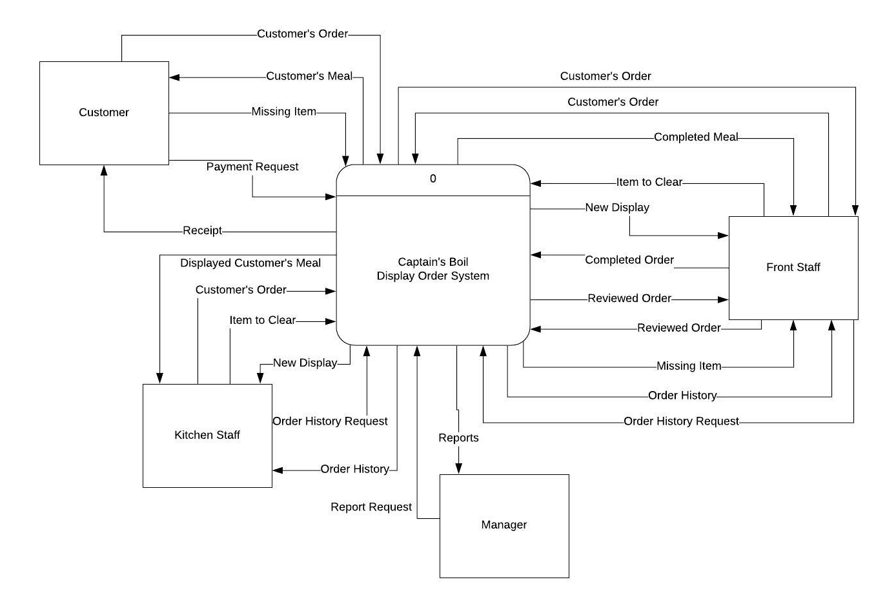

**Figure 1: DFD Context Diagram**

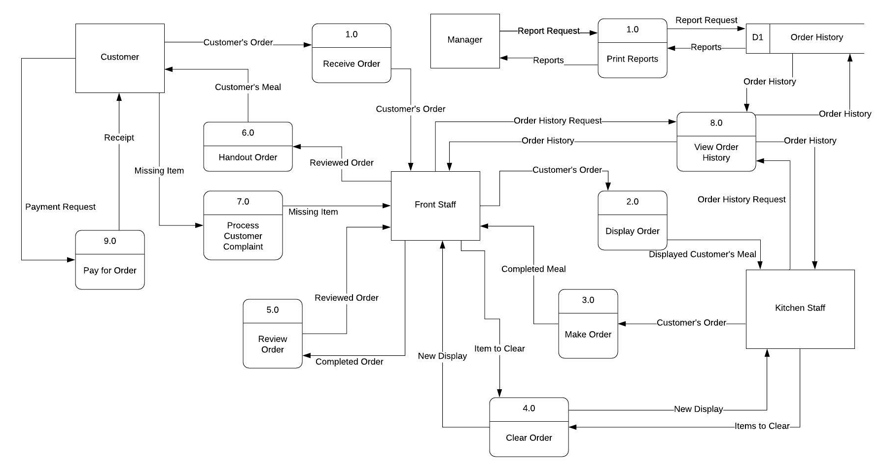

**Figure 2: DFD Logical Process Model (Level 0)**

**Development Strategy**

At this phase of the design strategy, the company must examine the optimal way of procuring the

appropriate system that meets the organization's exact requirements. The company must decide between

the following three options: custom development, outsource development, and purchase software

package.

**Custom Development**

The first strategy proposed is to in-house develop the new electronic based system. The benefits

of this would be the accuracy in which you can tailor the system to the organizational needs. The

developers can create a system that satisfies the unique business requirements of the restaurant. Although

this strategy would yield the most efficient system, it would also be the far most costly option.

Additionally, the restaurant must currently employ professionals that have the capabilities of designing

and building such a system.

**Outsource Development**

The second strategy that the organization should consider is hiring an external developer to

supply the custom system. The restaurant would provide the business requirements that the outsourcing

developer must follow. Outsourcing the custom development would ensure that the system is being

designed by a professional with experience in the system design field. It would also eliminate the

requirement of already having an employee with the ability to design said system. However, considering

the system is being designed by someone outside the organization, the system is likely to be less accurate

in meeting the specific business needs. This option is also quite costly, although not as costly as the

custom development option.

**Purchase Software Package**

Finally, the organization has the option of purchasing a pre-existing software package. If the

organization has business needs that aren’t unique then a cost-efficient pre-existing system should fill the

needs of the company. Captain’s Boil operates within the restaurant industry, therefore the likelihood is

very high that there is a pre-existing system that they can purchase that will fulfill all their needs. This

strategy would ensure swift implementation of the system and would also be the most cost effective.

Additionally, most packaged applications allow for some customization. This means that the restaurant

would have the option of integrating elements of the current system that the pre-existing system may lack.

**Sample Alternatives Matrix**

To determine the optimal strategy for the company, a sample alternative matrix has been created.

This decision-making tool identifies the key evaluation criteria and assigns the appropriate weight to each

criteria to determine its influence power.

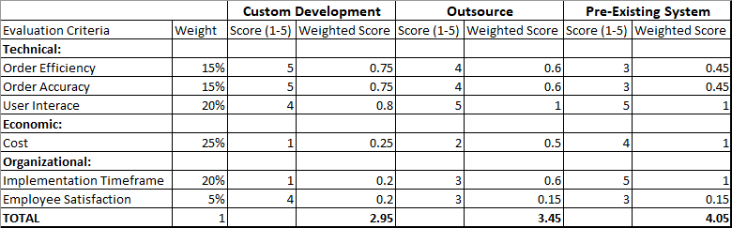

**Table 6: Sample Alternative Matrix for Determining Development Strategy**

Through this decision-making tool, it is determined that *purchasing a pre-existing system would*

*be the optimal strategy*. It satisfies the important needs of the restaurant by obtaining a low-cost system in

a short period of time that has capable technical requirements.

**Database Design**

Since, the company is purchasing a pre-packaged product, the company should try and procure a

system that can store the correct data and have an application that can query that database when required

for the necessary order reviews or analytic reports. An example of how that database’s design might look

like is the following:

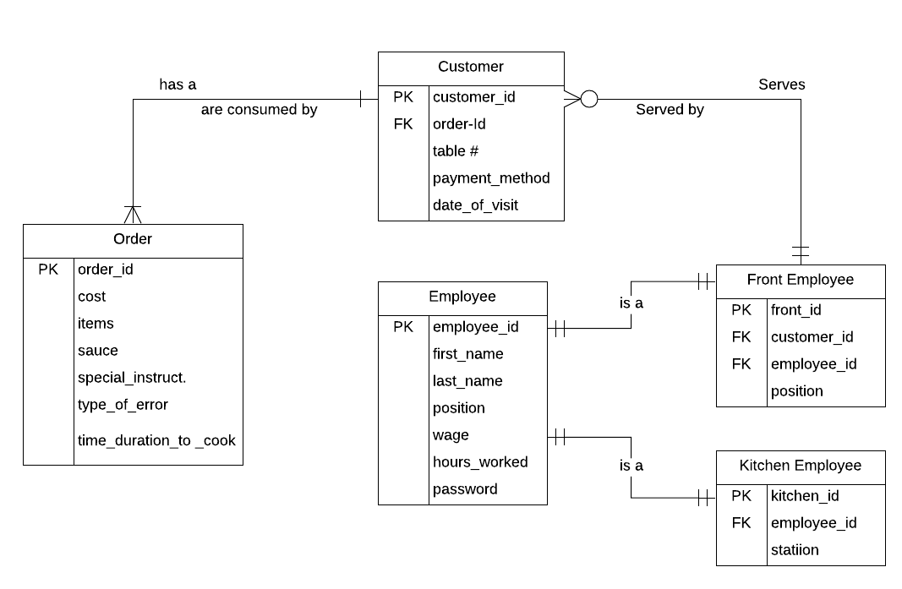

**Figure 3: Entity Relationship Diagram for Order System Database**

The application can use a relational database stored on the server side of the application (either in

Cloud, or an in-house server procured at time of acquisition), that uses data access logic queries –

using JDBC/ODBC depending on language -- to produce analytic reports based on the data stored.

Having the database will allow the application to store a diverse range of information on employees,

customers, food costs, food item errors, wages, etc. The application will automatically run embedded

SQL queries when “Reports” or “View Past Orders” are selected from a user interface and will also store

employee clock-in/clock-out times of when an employee logs into or out of their account.

**System Architecture**

Moving on from the logical model and onto the physical model, determining the architecture of a

a project is a vital task. The following is an example of what management could look for when procuring

the proper technology.

|  |  |
| --- | --- |
| Hardware | * 4 kitchen touch-screen monitors * 4 I-pad-like tablets * 1 main monitor (POS, clock-in/out reports) * Controller * Server (in cloud) * Cables |
| Client/Server Architecture | * **2-tier Architecture:** (1 server, multi-client), * **Cloud Virtualization:** Software as a Service: handles data storage, data access, and presentation and application logic. * 1 server as there is not a significant amount of data storage, access and other services to perform to require multiple servers (e.g. web server service, application logic with Java) |

**Table 7: Hardware & Client/Server Architecture**

|  |  |  |  |  |
| --- | --- | --- | --- | --- |
|  | **Main Client (POS, reports,etc)** | **Front Staff Tablet Clients** | **Kitchen Monitor Clients** | **Server** |
| **Operating System** | * iOS | * iOS | * iOS | * Linux |
| **Special Software** | * Provided by server | * Provided by server | * Provided by server | * Apache * Java * Oracle |
| **Hardware** | * 10.20-inch LED multi-touch display * A10 Fusion chip (64-bit) | * 10.20-inch LED multi-touch display * A10 Fusion chip (64-bit) | * 10.20-inch LED multi-touch display * A10 Fusion chip (64-bit) | * 8 TB disk drive * RAID * Xeon E5-4600 v4 |
| **Network** | * Intranet to server * dual band (2.4GHz and 5GHz); HT80 with MIMOBluetooth 4.2 technology | * Intranet to server * dual band (2.4GHz and 5GHz); HT80 with MIMOBluetooth 4.2 technology | * Intranet to server * dual band (2.4GHz and 5GHz); HT80 with MIMOBluetooth 4.2 technology | * Dual 100 Mbps Ethernet |

**Table 8: Hardware & Software Specifications**

**User Interface Design**

The following interfaces are solutions of what a desired User Interface might look like when

procuring the appropriate technology and software:

**Main Monitor:** The servers and head chef interact with this interface on a touchscreen display monitor.

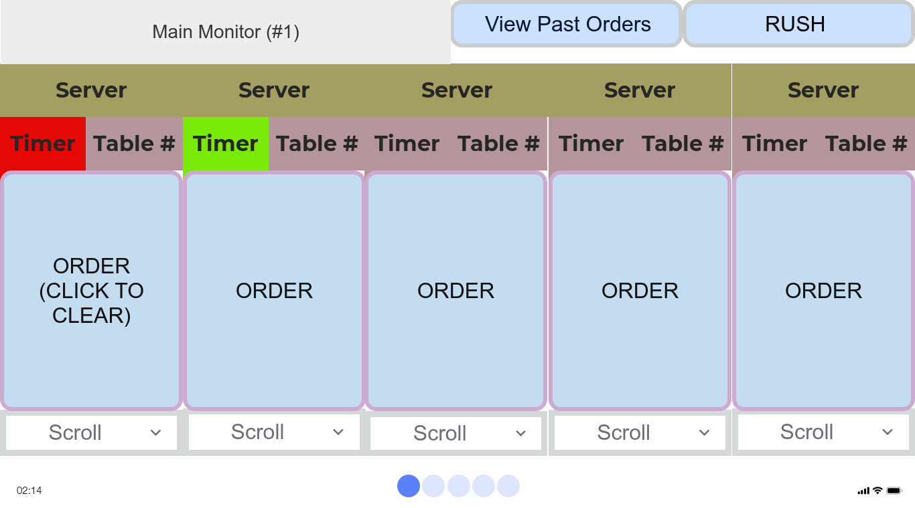

**Figure 4: Main Monitor User Interface**

Once a customer’s order has been inserted by the front staff into an I-Pad device, the order is sent

to the main monitor. This interface displays the *server* that the order belongs to, as well the *timer* showing

how longthe order has been active; red meaning the order timer has completed, and green meaning the

order is in progress. The head chef can manage the orders by pressing “RUSH”, which will prioritize the

order on the respective monitors for each station. “View Order History” allows front staff to view

previous orders. A large order may be expanded by pressing “scroll” to scroll down and see the rest of the

order. Finally, once the order is deemed acceptable, the server may clear an order by clicking on the

“order”, only when the timer is red.

**Sauce/Seafood/Fryer Station Monitors:**

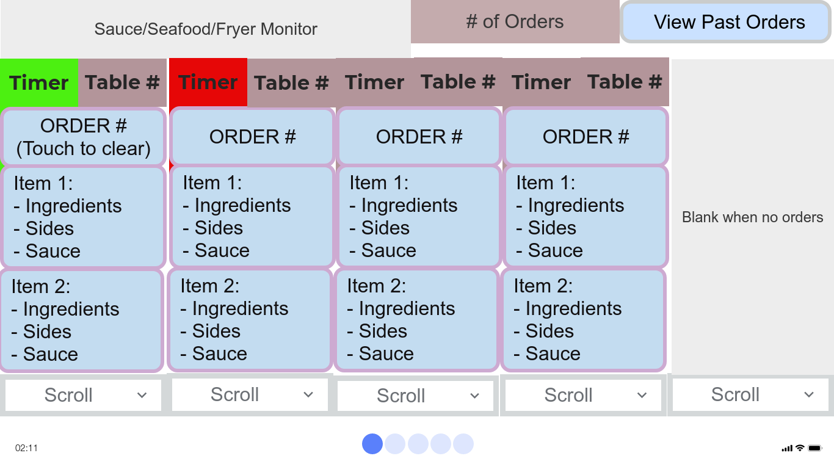

**Figure 5: Station Monitors User Interface**

Once an order is inserted by front staff, the order is also delegated to the appropriate station. The

the customer's order will be delegated depending on the nature of the item: seafood or fryer food. Once a

food item has begun cooking, the cook should press the “order” to begin the timer. The order is then

relayed to the sauce station monitor, with the same interface, where the sauce maker can read the order

and make the proper sauce. The sauce monitor times an order out in 5 seconds, and the other monitors

timers turn red when the order is complete. When the timer is red, the cook can clear the order. Past

orders can be viewed as well. When complete, orders are brought to the main monitor station for review.

**Tablet User Interface:**

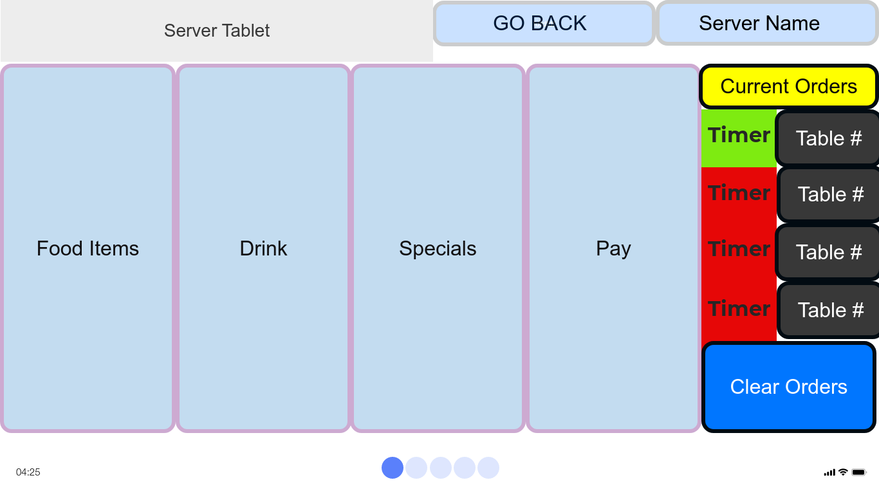

**Figure 6: Tablet User Interface**

Front staff can use the tablet interface to select different food items, drinks, and specials for the

customer. The tablet shows the current orders that server has and how far along in the cooking process

each order is along. Finally, the tablet has a “Pay” section to get the bill.

**Security & Performance**

**Security Issues**

As part of the overall ordering system, the POS sub-system is the most vulnerable. The reason for

this is due to financial incentive; not much incentive to hack the kitchen display system unless to troll, but

also due to good firewall security. To mitigate this concern, when the company is purchasing it can ensure

that appropriate security measures are implemented.[1] Some measures to consider: using an I-pad (the O.S.

runs one app at a time making hacking more troublesome); use end-to-end encryption; ensure POS system

complies with Payment Card Industry Data Security Standards (PCI DSS); have separate accounts for

staff members. On top of this, at the end of the day the POS system should be shut down to prevent

potential attacks (e.g. if a tablet device was stolen).

**Types of Maintenance Issues**

As a result of the software and hardware being bought externally, and as a result of Captain’s Boil

lacking the technical capacity to perform its own maintenance, maintenance will require outsourcing.

What is usually the largest source of maintenance for a company, *corrective* maintenance may not be a

large issue if management purchases a system with care. Choosing a system that has been in the market

for a while will likely have a lot if its bugs worked out and not require as much repair. In the case that

repair is required, technical expertise can be called. Some of the corrective issues that may arise are:

defective networks cables, restoring proper configuration settings, broken hardware, and latent defects

with software. With regards to *perfective* maintenance, the company may wish to update software, replace

old hardware, or upgrade to a wireless network for the kitchen monitors (if not already in budget) in

order to perfect performance. To account for *adaptive* maintenance, adapting to the ever evolving

restaurant industry should be to be considered. Remaining competitive with other companies is key, and

as such, the company should prepare for any changes that may come. Being conscious of new technology

and adopting it is key. In terms of *preventative* maintenance, the system can install new antivirus software

before needed. The server should have frequent backups for data (potential cloud strategies). A manager

can also take precautions by checking the hardware frequently to ensure it is being taken care of (in a safe

place, cables are out of the way, cables are tightened, etc.), and report on the system failures (types,

timing, and mean time between failures) if the system doesn’t already automate this process itself.

**Cost of Maintenance**

Many factors may affect the cost of maintenance. The system may always have latent defects in

it’s software and hardware, resulting in necessary corrective measures. The software system is designed to

work with more customers than should ever be using it at one time, and so numbers of customers

shouldn’t cause too many issues on the technical part of the system. The system is also designed to

minimize costs that were incurred with the previous system. Documentation and high quality

programming personnel can be provided by the technology vendor to help employees use the product, so

the degree to which bad documentation can contribute to a high cost is dependent upon the vendor.

**Implementation Plan**

To get the system in place, the company should obtain the and install the integrated POS and

Kitchen Display System. This can be installed during closing hours and should take about a day. Next the

system should be tested, follow by the training of employees. Finally, management should develop a

contingency plan.

**Budget**

Many plans were found for purchasing integrated POS/Kitchen Display Systems. The estimates

given are based on some of these vendors, of which the company may use as a reference for the purchase

of the project. See Appendix C for references to Vendors.

|  |  |  |
| --- | --- | --- |
|  | **Increase in Sales & Decrease in Costs** | **Expenses** |
| **Upfront** | **n/a** | **POS hardware: 1500**  **Extra Tablets: $900**  **Transportation & Installation: $600**  **Total = $3000** |
| **Monthly** | **5% Revenue Increase:**  **$7500/month**  **Decrease in Waste:**  **$1500/month**  **Decrease in Employee Turnover:**  **$500/month**  **Total/month: $8500/month** | **KDS: $20/station (software & hardware) = $80/month**  **POS software: $60/month**  **Maintenance + Utilities:**  **$1000/year => $83/month**  **Total/month: $223/month** |
| **TOTALS** | **$8500/month** | **$3000 Upfront + $223/month** |

**Table 9: Implementation Budget**

**Example Timeline**

|  |  |  |  |  |  |
| --- | --- | --- | --- | --- | --- |
| **Procure** | **Transportation** | **Installation** | **Adjustment/**  **Training** | **Maintenance** | **TOTAL** |
| 1st week | 2nd week | 1-2 days | 2 weeks | Ongoing | 1 month |
| May 1st - May 7th | May 8th - May 14th | May 15th - May 16th | May 17th - May 30th | n/a |

**Table 10: Timeline: Procurement, Implementation and Maintenance**

**Appendix A: Extra Diagrams**

**As-is System Components at Captain’s Boil:**

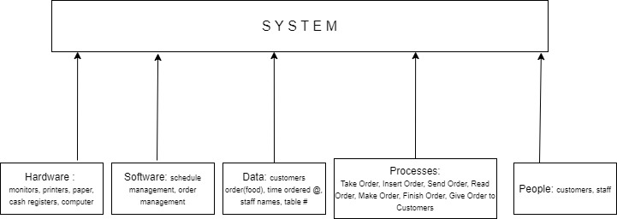

**Figure 1: As-is Order System at Captain’s Boil**

**Kitchen Layout:**

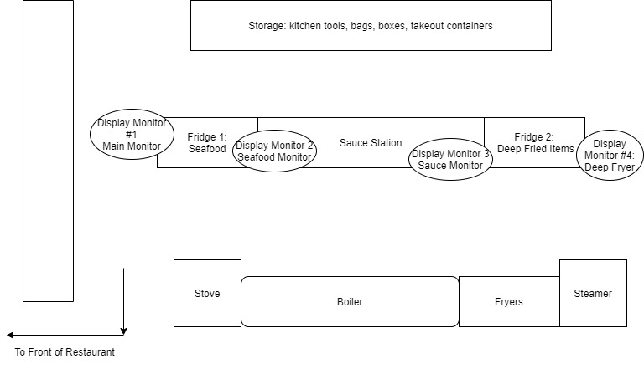

**Figure 2: Kitchen Layout + Proposed Locations of Monitors**

**Client-Server Architecture:**

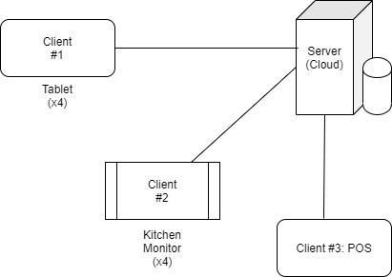

**Figure 3: Client/Server Architecture of Proposed Solution**

**Appendix B : Techniques**

**Requirement Elicitation Techniques Used :**

1. Observation: as a current worker at the restaurant, Steve was able to observe the current system requirements and what could be improved on.
2. Interview/User feedback: small interviews were conducted with respective managers at the restaurant to help develop requirements below

**Requirements Analysis Strategies Used:**

1. Problem Analysis: customers(users) complaints were taken seriously on how to improve business, based on their experience as users of the as-is system. Also, as users ourselves we were able to experience the system as users.
2. Duration Analysis: was used to determine how actual order times were not meeting expectations (e.g. summation of times between input of order into system, initializing cooking, preparing sauces, finishing the meal, and delivering to customer are slower than expected)
3. Benchmarking & Technology Analysis: observed other restaurant methods to dealing with the above issues (e.g. new technology such as display systems in kitchen, and “I-pads”)
4. Outcome analysis: looked at the user experience from the customer’s perspective

**Appendix C: References**

Denis, A., Roth, R.M., Wixom, B.H. (2012). System Analysis & Design (5th ed.). John Wiley & Sons, Inc.

How Much Does a POS System Cost. Merchant Maverick. Retrieved March 30, 2020, from

<https://www.merchantmaverick.com/how-much-does-a-pos-system-cost/>

KDS/Kitchen Solution. Par Technology. Retrieved March 30, 2020, from

<https://www.partech.com/brink-pos/kitchen/>

Kitchen Display System. Sintel Systems. Retrieved March 30, 2020, from

<https://sintelsystems.com/kitchen-display-system-pos-kds>

Martinez, J., & Sevilla, G. (2019, November 30). 7 Steps to Securing Your Point of Sale System. PCMag.

<https://www.pcmag.com/news/7-steps-to-securing-your-point-of-sale-system>.

POS Pricing. Lightspeed HQ. Retrieved March 30, 2020, from

<https://www.lightspeedhq.com/pos/restaurant/pricing/>

1. (n.d.). 7 Steps to Securing Your Point-of-Sale System | PCMag. Retrieved April 1, 2020, from <https://www.pcmag.com/news/7-steps-to-securing-your-point-of-sale-system>